***A Mini Project Synopsis on***

**Language Solutions**

**S.E. - I.T Engineering**

**Submitted By**

**Shivani Zagade Moodle ID:21104021**

**Ankita Semwal Moodle ID:21104130**

**Mrunal Shardul Moodle ID:21104037**

**Under The Guidance Of :**

**Prof. Roshna Sangle**



**DEPARTMENT OF INFORMATION TECHNOLOGY**

A.P.SHAH INSTITUTE OF TECHNOLOGY

G.B. Road, Kasarvadavali, Thane (W), Mumbai-400615

UNIVERSITY OF MUMBAI

**Academic year: 2022-23**

**CERTIFICATE**

This to certify that the Mini Project report on **Language Solutions** has been submitted

by Ankita Semwal(21104130), Shivani Zagade (21104021) and Mrunal Shardul

(21104037) who are a Bonafide students of A. P. Shah Institute of Technology,

Thane, Mumbai, as a partial fulfilment of the requirement for the degree in

**Information Technology**, during the academic year **2022-2023** in the satisfactory

manner as per the curriculum laid down by University of Mumbai.

Prof. Roshna Sangle

Guide

Dr. Kiran Deshpande Dr. Uttam.D.Kolekar

Head Department of Information Technology Principal

External Examiner(s)

1.

2.

Place: A.P. Shah Institute of Technology, Thane

Date:

**ACKNOWLEDGEMENT**

This project would not have come to fruition without the invaluable help of our guide

Prof. Roshna Sangle. Expressing gratitude towards our HoD, **Dr. Kiran Deshpande**,

and the Department of Information Technology for providing us with the opportunity

as well as the support required to pursue this project. We would also like to thank our

teacher Ms. Rujata Chaudhari who gave us her valuable suggestions and ideas when

we were in need of them. We would also like to thank our peers for their

helpful suggestions.

**TABLE OF CONTENTS**

1. Introduction.......................................................................................................... 1

1.1. Purpose..................................................................................................... 1

1.2. Objectives................................................................................................. 1

1.3. Scope........................................................................................................ 2

1. Problem Definition………………….................................................................... 3
2. Proposed System………....................................................................................... 4

3.1. Features and Functionality…………………………………………………. 4

1. Project Outcomes.................................................................................................. 7
2. Software Requirements ........................................................................................ 8
3. Project Design........................................................................................................9
4. Project Scheduling..................................................................................................15
5. Conclusion..............................................................................................................16

References

**Chapter 1**

**Introduction**

Our project is designed to help you improve your writing and communication skills by providing three key features: a language translator, a spelling auto-corrector, and a dictionary.

With our language translator, you can easily translate any text or document from one language to another. Simply select the source and target languages, paste your text, and hit translate. Our tool uses state-of-the-art translation technology to ensure accurate and reliable translations. Our spelling auto-corrector is perfect for anyone who struggles with spelling errors. Simply paste your text into the tool, and it will automatically identify and correct any spelling mistakes. This feature is especially useful for people who are learning a new language or for those who want to ensure their writing is error-free. Finally, our dictionary is an essential tool for anyone looking to expand their vocabulary. Simply type in a word, and our tool will provide you with a definition and any related synonyms. This is a great tool for students, writers, and anyone who wants to improve their language skills. This feature allows users to translate text from one language to another. The user will input the text they want to translate, select the input language, and then select the output language. The code will then use the translation library to convert the input text into the output language and return the translated text to the user.

This feature helps users correct any spelling mistakes in their text. When a user inputs text, the code will check each word against a dictionary and flag any misspelled words. It will then suggest the correct spelling for each word, and the user can choose to accept the suggestion or keep the original spelling. Talking Dictionary allows users to look up the definitions of words they are not familiar with. The user can input the word they want to look up, and the code will return the definition of the word from a pre-existing dictionary.

Finally, our dictionary is an essential tool for anyone looking to expand their vocabulary. Simply type in a word, and our platform will provide you with a definition and any related synonyms. This is a great feature for students, writers, and anyone who wants to improve their language skills.

In addition to these three key features, our platform also offers a user-add word game and text-to-speech functionality. The user-add word game allows you to test your vocabulary knowledge by adding new words to our platform's dictionary. The text-to-speech functionality allows you to listen to the correct pronunciation of words and phrases in multiple languages.

Overall, these features work together to make it easier for users to work with text in different languages and formats, and to improve the accuracy and clarity of their written communication.

**1.1. Purpose:**

The purpose of the code is to provide users with a language translator, spelling auto-corrector, and a dictionary. The language translator allows users to input text in one language and receive a translation in another language. This can be useful for communication with individuals who speak a different language, or for translating text from a foreign language. The spelling auto-corrector helps users avoid spelling errors in their text by suggesting corrections for misspelled words. This can be especially useful for individuals who struggle with spelling or who are writing in a language that they are not fluent in. The dictionary feature allows users to look up the definition of words, which can be helpful for expanding vocabulary or understanding the meaning of unfamiliar words. The main need of the system is to eliminate language barriers and ensure communication between people who speak different languages. The word game feature is a fun and interactive way for users to improve their language skills. It presents users with a series of words or phrases to unscramble or guess, which can be a helpful way to improve vocabulary and language comprehension. The text-to-speech feature allows users to input text and have it read back to them in a natural-sounding voice. This can be useful for individuals who have difficulty reading or who prefer to listen to text rather than read it.

**1.2. Objectives:**

* To provide accurate translations of text from one language to another.
* To identify and correct spelling and grammar mistakes made by the user while typing, so that the text is easier to read and understand.
* To be designed with the aim of providing a user-friendly, regardless of their level of technical knowledge.
* To have a platform that will be optimized to ensure the best possible performance and user experience, while also providing a modern and aesthetically pleasing layout.
* To have a platform that provides language learners improve vocabulary and spelling.
* To save time by correcting spelling and translating text.
* To help users understand information in a language they don't speak fluently, allowing them to access a wider range of content and resources.
* To help language learners avoid common spelling errors and learn the correct spelling of words.
* To save time by quickly translating text, eliminating the need for manual translation.
* To assist users who have difficulty reading or are visually impaired. It converts written text into speech, allowing users to listen to written content instead of reading it.
* To help users to consume content in a more convenient and efficient way.

**1.3. Scope:**

* Can help users learn a new language by providing accurate translations and correcting their mistakes.
* Can be especially useful for people who are not native speakers of the language they are writing in.
* Can help ensure that the content is accurately translated and free of errors, making it easier for people to access and understand the information.
* Can provide accurate definitions and additional features to help users search for definitions in real-time.
* Can help users translate written text into spoken words.
* Can help Individuals with visual impairments or reading challenges, as well as language learners who want to hear the correct pronunciation of words and phrases.

**Chapter 2**

**Problem Definition**

The problem that the above code aims to solve is to provide a convenient tool for users to perform various language-related tasks, such as translation, spelling correction, and dictionary lookup, all in one place. The users may face difficulties while communicating or writing in a foreign language, which can lead to misunderstandings and errors. This code aims to alleviate such issues by providing a platform for users to easily translate text, correct spelling errors, and access the meanings of words in their native language. The problem being addressed by the code is the difficulty that users may face when communicating in a language that is not their native language. Specifically, the code is intended to address three related issues that users may encounter Users may need to communicate with people who speak a different language, and may have difficulty understanding or conveying their message. The language translation feature of the code aims to help users overcome this difficulty by allowing them to input text in one language and receive an accurate translation in another language. Users may make spelling errors when typing, which can lead to miscommunication or difficulty understanding the message. The spelling auto-correction feature of the code aims to help users avoid these errors by automatically suggesting corrections for misspelled words. Users may want to improve their language skills, including vocabulary and spelling, through engaging activities. The word game feature of the code aims to provide an enjoyable and educational experience for users to enhance their language skills. The text-to-speech feature of the code aims to help users overcome this difficulty by allowing them to hear the correct pronunciation of words and phrases.

Overall, the goal of the code is to provide users with a comprehensive solution to various language-related challenges, including communication, learning, and skill-building, in a convenient and accessible way.

**Chapter 3**

**Proposed System:**

The proposed system for the above code is a language translation, spelling autocorrect, and dictionary tool for users. This system allows users to easily translate text from one language to another, correct any spelling mistakes, and look up definitions for words. It is designed to be user-friendly, efficient, and accurate, providing users with a seamless experience for their language needs. The system utilizes advanced algorithms and machine learning techniques to ensure accurate translations, spellings, and definitions, making it a valuable tool for users who need to communicate or write in different languages. The proposed system using the above code aims to provide users with a comprehensive language translation, spelling auto-correction, and dictionary tool.

The system will be able to translate text from one language to another, correct spelling errors in the text, and provide definitions of words that are not familiar to the user. The users will be able to input text into the system, either by typing it into a text box or by uploading a document. The system will then process the text and provide the user with the translated text, corrected text, and definitions of any unfamiliar words. The proposed system will be user-friendly, with an easy-to-use interface that allows users to easily input text and receive the desired output. The system will also be fast and accurate, providing users with accurate translations, spellings, and definitions. Text-to-speech feature to hear the correct pronunciation of words. The word game feature will allow users to learn and practice new vocabulary in a fun and engaging way. The game will test the user's knowledge of words and their meanings, helping them to expand their vocabulary and improve their language skills.

Overall, the proposed system will provide users with a valuable tool for learning and practicing different languages, improving their written communication by correcting spelling errors, expanding their vocabulary by providing definitions of unfamiliar words, and making it easier for them to communicate effectively with others.

**3.1. Features and Functionality:**

Users can input text in one language and get it translated into another language of their choice. Users can input text with spelling errors and get suggestions for corrected spellings. Users can search for meanings of words they don't know or are unsure of. The code has a simple and intuitive interface that makes it easy for users to interact with and obtain the desired results. The code supports a variety of languages for translation, spelling correction, and dictionary search, making it useful for users with diverse language needs. The code provides quick and accurate results, enabling users to save time and improve the quality of their work. Users can customize the code by adding new languages, words, or phrases to the dictionary or changing the settings for translation or spelling correction based on their preferences Overall, the code provides users with a convenient and efficient tool for language-related tasks, making it ideal for individuals, businesses, and organizations that work with multiple languages. Users can input text in one language and get the translation in the desired language. This feature is useful for individuals who are communicating with others who speak different languages, such as in international business or travel.

The system will automatically detect and correct any spelling mistakes in the user's input text. This feature is useful for individuals who may have difficulty spelling certain words or for those who are typing quickly and make mistakes. The system will allow users to look up definitions of words they are unsure of or unfamiliar with. This feature is useful for individuals who are reading or writing in a language that is not their native language or for those who are looking to expand their vocabulary. The system provides a simple and intuitive interface for users to input their text and select the desired language or dictionary lookup. This makes the system easy to use for individuals with different levels of technical expertise. The system is designed to provide fast and accurate translations, spelling corrections, and dictionary lookups. The system includes a word game that allows users to practice and improve their vocabulary in different languages. This feature can make learning new words and phrases more fun and engaging. The system includes a text-to-speech feature that allows users to listen to the translated text or the definition of a word. This feature can be helpful for individuals who have difficulty reading or pronouncing words in a different language.

Overall, features and functionalities of the system aim to provide a comprehensive language tool that can help users improve their language skills, communicate effectively with others, and have fun while learning new words and phrases.

**Chapter 4**

**Project Outcomes:**

The language translator feature would allow users to communicate effectively with people who speak different languages, making it easier to understand each other. Accurate spelling correction: The spelling auto-corrector would help users to write error-free messages and documents, enhancing their communication skills. The taking dictionary feature would allow users to learn new words and phrases, expanding their vocabulary and improving their language skills.

The integrated features in this project would save time for users in terms of language translation, spell checking, and dictionary search, making their work more efficient. With accurate spell checking and an extensive dictionary, users can focus more on the content of their message or document, increasing their productivity. With the support of this project, users can communicate more effectively, write more accurately, and expand their vocabulary, which can lead to increased confidence in their language skills. The addition of a word game and text-to-speech feature would increase user engagement with the system, making it more enjoyable and motivating to use. With the word game and text-to-speech feature, users can practice speaking and listening in addition to reading and writing, improving their overall language fluency.

Overall, the project outcomes for users are improved language skills, increased efficiency and productivity, and greater confidence in communication. With the addition of the word game and text-to-speech feature are improved language skills, accessibility, engagement, fluency, and user satisfaction.

**Chapter 5**

**Software Requirements:**

1. Python

2. PyCharm IDE

3. Tkinter

**Chapter 6**

**Project Design:**

**1. Language Translator**

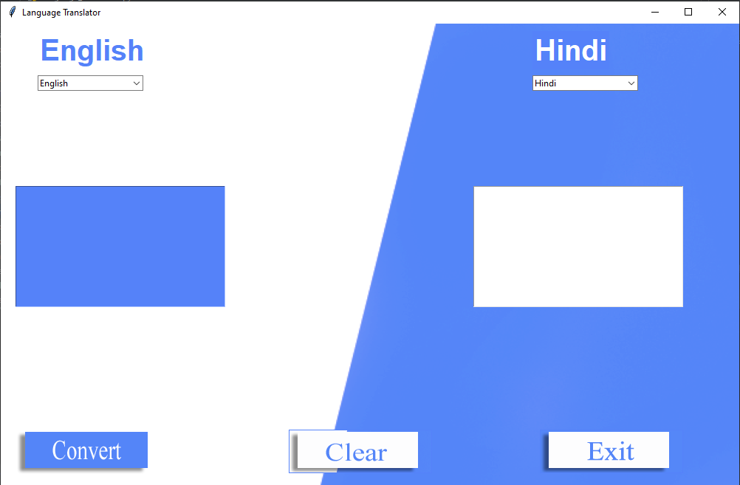

**2. Spelling Autocorrector**

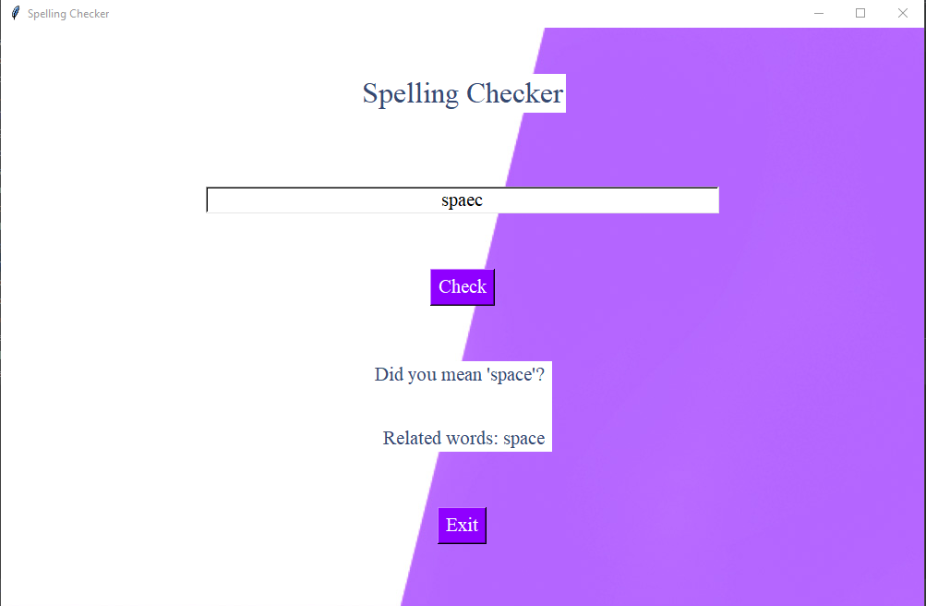

**3. Taking Dictionary**

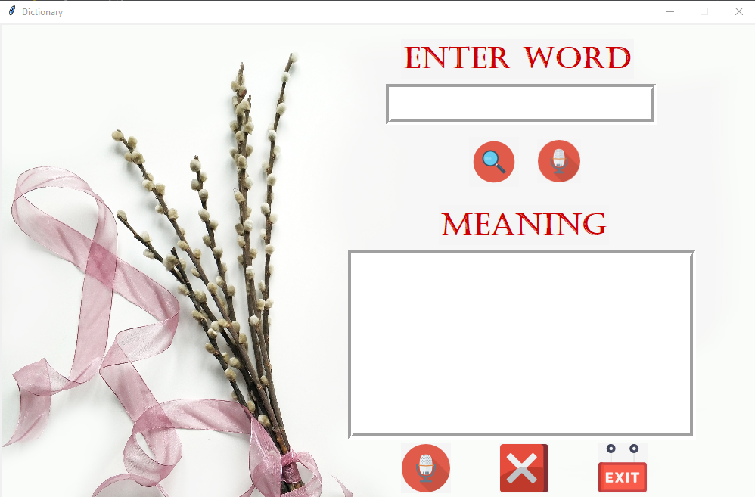

**4. Word game**

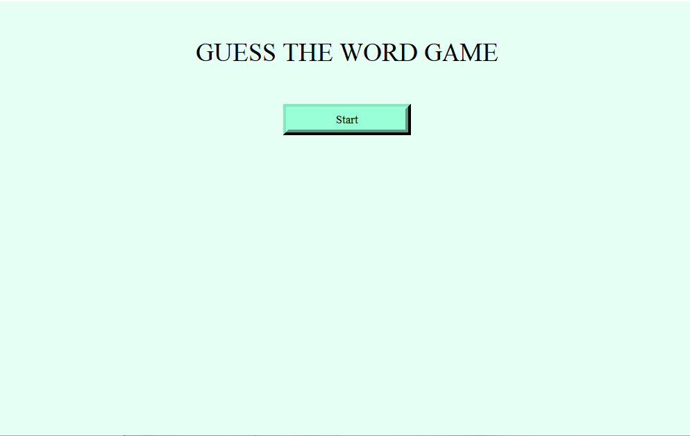

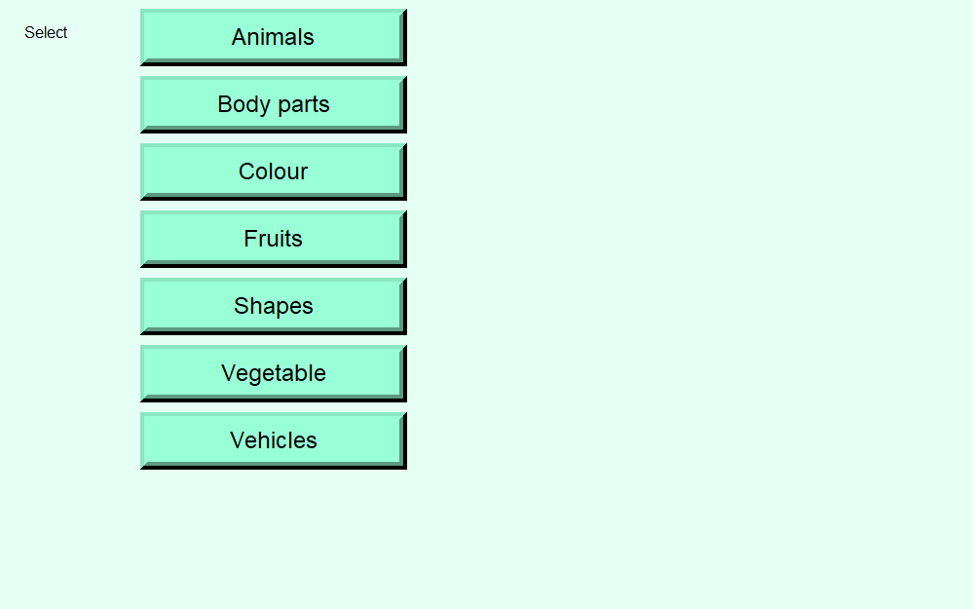

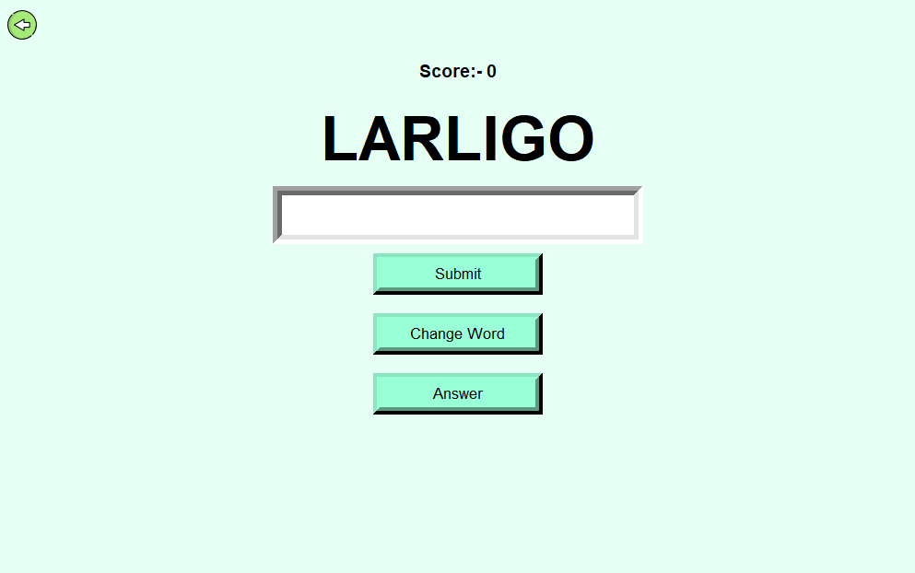

**5. Text to Speech**

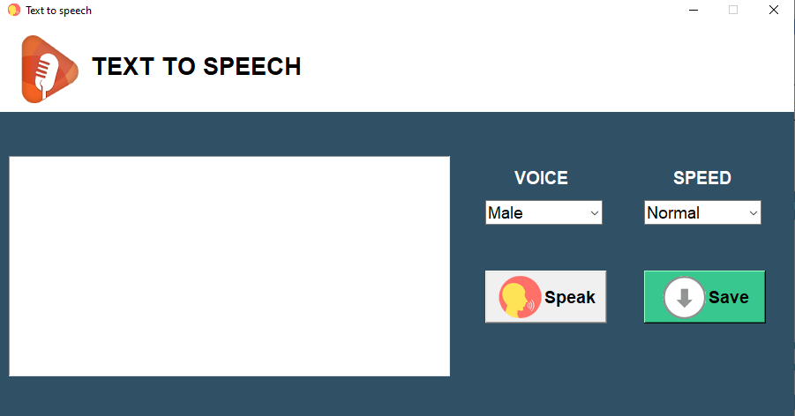

**6. Homepage**

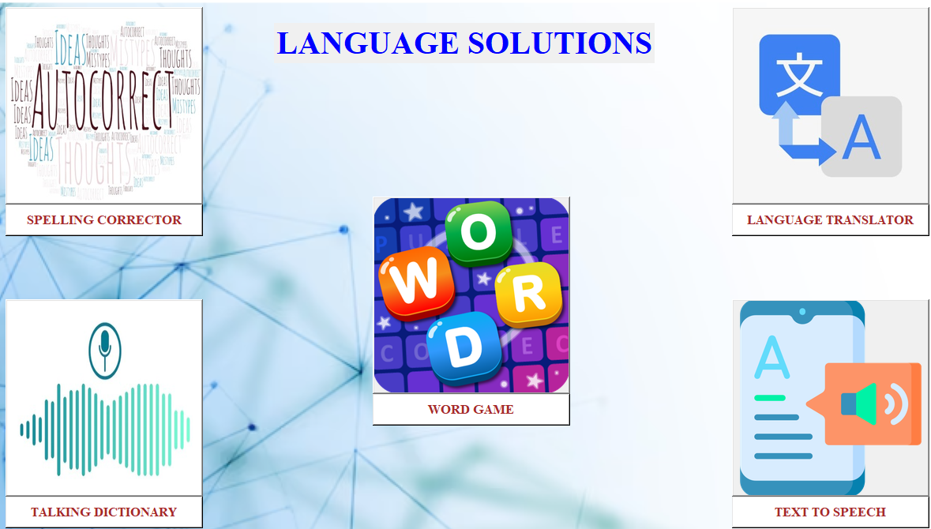

**Chapter 7**

**Project Scheduling:**

|  |  |  |  |
| --- | --- | --- | --- |
| **Sr. No** | **Group Member** | **Time duration** | **Work to be done** |
| **1.** | Shivani Zagade  Mrunal Shardul  Ankita Semwal | January | Creating GUI using Tkinter design of Language translator, Spelling Autocorrector, Taking dictionary. |
| **2.** | February | Adding more features like Word Game and Text to Speech. |
| **3.** | March and April | Adding data sets and final completion of project. |

**Chapter 8**

**Conclusion:**

In conclusion, the language translator, spelling auto-corrector, and dictionary project can be a useful tool for users who need to communicate in different languages or want to improve their writing skills. It provides an easy-to-use interface that allows users to translate text, correct spelling mistakes, and look up definitions of words. The project utilizes machine learning algorithms to improve the accuracy of translations and auto-corrections over time.

Overall, the project can save users time and effort, especially when dealing with multilingual communication or writing tasks. It can also help users expand their vocabulary and improve their language skills by providing definitions of words they may not be familiar with. With regular updates and improvements, this project has the potential to become a valuable asset for users in various settings, such as education, business, and personal communication. This project is about developing a utility that is capable of translating text into different languages and auto correcting any mistakes made in the text. This project will be beneficial for anyone who wants to communicate with people from different countries and cultures. The word game feature adds an element of fun and engagement, making it easier for users to learn new words and phrases. The text-to-speech feature allows users to listen to their text and make necessary edits, improving the accuracy and clarity of their writing.

In conclusion, a powerful tool help users to improve their language skills and communicate more effectively, regardless of their level of proficiency. The integrated features make the tool comprehensive, user-friendly, and efficient, providing users with a seamless experience for their language needs.

**References**

[1] Michael Picheny “[Automatic language translation for user interfaces | IEEE Conference Publication “| IEEE Xplore](https://ieeexplore.ieee.org/document/1570880)

[2] [Create and run your first Python project | PyCharm Documentation (jetbrains.com)](https://www.jetbrains.com/help/pycharm/creating-and-running-your-first-python-project.html)

[3] Kevin Duh and Shinji Watanabe “[Multilingual End-to-End Speech Translation” | IEEE Conference Publication | IEEE Xplore](https://ieeexplore.ieee.org/abstract/document/9003832)

[4] Jayashree Nair “[An efficient English to Hindi machine translation system using hybrid mechanism” | IEEE Conference Publication | IEEE Xplore](https://ieeexplore.ieee.org/document/7732363)